**DATABASE MANAGEMENT SYSTEMS**

**Name: M KAUSHIK REDDY**

**Register number: 192325014**

**Question 1:**

**ER Diagram : Traffic Flow Management System (TFMS)**

**Scenario**

You are tasked with designing an Entity-Relationship (ER) diagram for a Traffic Flow Management System (TFMS) used in a city to optimize traffic routes, manage intersections, and control traffic signals. The TFMS aims to enhance transportation efficiency by utilizing real-time data from sensors and historical traffic patterns.

The city administration has decided to implement a TFMS to address growing traffic congestion issues. The system will integrate real-time data from traffic sensors, cameras, and historical traffic patterns to provide intelligent traffic management solutions.

**Answers:**

**Task 1: Entity Identification and Attributes**

**Entities and their Attributes:**

**1. Roads:**

- RoadID(PK): Unique identifier for each road

- RoadName: Name of the road

- Length: Length of the road in meters

- SpeedLimit: Maximum speed limit in km/h

**2. Intersections:**

- IntersectionID(PK): Unique identifier for each intersection

- IntersectionName: Name of the intersection

- Latitude: Geographic latitude of the intersection

- Longitude: Geographic longitude of the intersection

**3. Traffic Signals:**

- SignalID(PK): Unique identifier for each traffic signal

- SignalStatus: Current status of the signal (Green, Yellow, Red)

- Timer: Countdown timer to the next signal change

- IntersectionID(FK): Foreign key referring to the IntersectionID in Intersections

**4. Traffic Data:**

- TrafficDataID (PK): Unique identifier for each traffic data entry

- Timestamp: Date and time when the data was collected

- Speed: Average speed on the road

- CongestionLevel: Degree of traffic congestion

- RoadID(FK): Foreign key referring to the RoadID in Roads

**Task 2: Relationship Modeling**

**Relationships and their Cardinality:**

**1. Roads to Intersections:**

- Relationship: Roads intersect at Intersections

- Cardinality: Many-to-Many (A road can be part of multiple intersections, and an intersection can be connected by multiple roads)

- Optionality: Mandatory on both sides (each intersection must be connected by roads and each road must connect to intersections)

**2. Intersections to Traffic Signals:**

- Relationship: Intersections have Traffic Signals

- Cardinality: One-to-Many (An intersection can have multiple traffic signals, but a traffic signal belongs to only one intersection)

- Optionality: Mandatory for Traffic Signals (each signal must be at an intersection), Optional for Intersections (an intersection may not have traffic signals at all times)

**3. Traffic Data to Roads:**

- Relationship: Traffic Data is collected for Roads

- Cardinality: Many-to-One (Multiple traffic data records can be associated with a single road)

- Optionality: Mandatory for Traffic Data (each data record must be associated with a road), Optional for Roads (a road might not have recent traffic data)

**Task 3: ER Diagram Design**

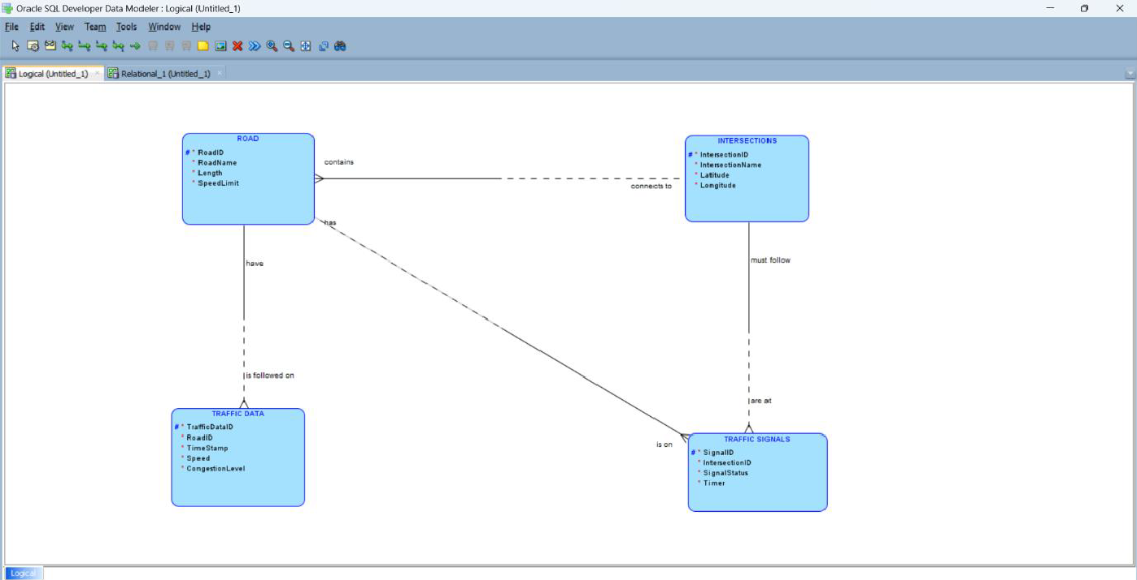

- Roads are connected to Intersections through a many-to-many relationship.

- Intersections are connected to Traffic Signals through a one-to-many relationship.

- Traffic Data is connected to Roads through a many-to-one relationship.

**Task 4: Justification and Normalization**

**Justification:**

**1. Scalability and Real-Time Data Processing:**

- The design allows for the addition of new roads, intersections, and traffic signals without affecting existing data.

- Traffic data is collected and stored in a way that supports real-time updates, ensuring that traffic conditions can be managed dynamically.

**2. Efficient Traffic Management:**

- The relationships ensure that traffic signals are managed at intersections and that traffic data is accurately linked to specific roads, facilitating better traffic management and route optimization.

**Normalization Considerations:**

**1. 1NF (First Normal Form):**

- Each table has a primary key, and attributes are atomic, ensuring no repeating groups or arrays.

**2. 2NF (Second Normal Form):**

- All non-key attributes are fully functionally dependent on the primary key. For example, Traffic Data attributes depend solely on the TrafficDataID, and not on other attributes.

**3. 3NF (Third Normal Form):**

- No transitive dependencies exist. For instance, Traffic Data attributes do not depend on non-key attributes of Roads.

**Conclusion:**

The ER diagram and associated design ensure data integrity, minimize redundancy, and support the key functionalities of the TFMS. The structure allows for efficient real-time data processing and supports future scalability as the city's traffic management needs evolve.

**Question 2:**

**Question 1: Top 3 Departments with Highest Average Salary**

**Step 1: Create Tables**

CREATE TABLE Departments (

DeptID INT PRIMARY KEY,

DeptName VARCHAR(100)

);

CREATE TABLE Employees (

EmpID INT PRIMARY KEY,

DeptID INT,

Salary DECIMAL(10, 2),

FOREIGN KEY (DeptID) REFERENCES Departments(DeptID)

);

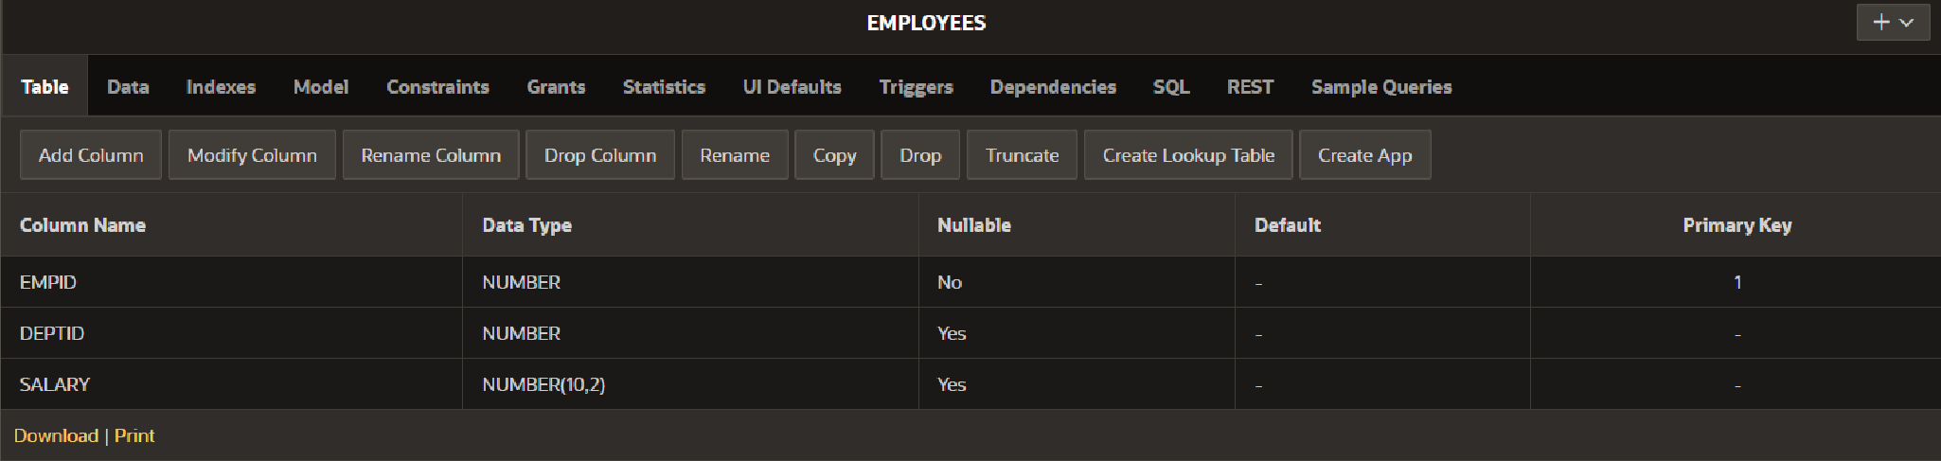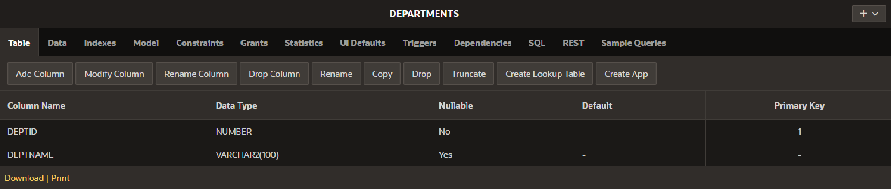

**Step 2: Insert Sample Data**

INSERT INTO Departments (DeptID, DeptName) VALUES (1, 'HR');

INSERT INTO Departments (DeptID, DeptName) VALUES (2, 'Engineering');

INSERT INTO Departments (DeptID, DeptName) VALUES (3, 'Sales');

INSERT INTO Departments (DeptID, DeptName) VALUES (4, 'Marketing');

INSERT INTO Employees (EmpID, DeptID, Salary) VALUES (1, 1, 50000);

INSERT INTO Employees (EmpID, DeptID, Salary) VALUES (2, 1, 60000);

INSERT INTO Employees (EmpID, DeptID, Salary) VALUES (3, 2, 80000);

INSERT INTO Employees (EmpID, DeptID, Salary) VALUES (4, 2, 90000);

INSERT INTO Employees (EmpID, DeptID, Salary) VALUES (5, 3, 70000); 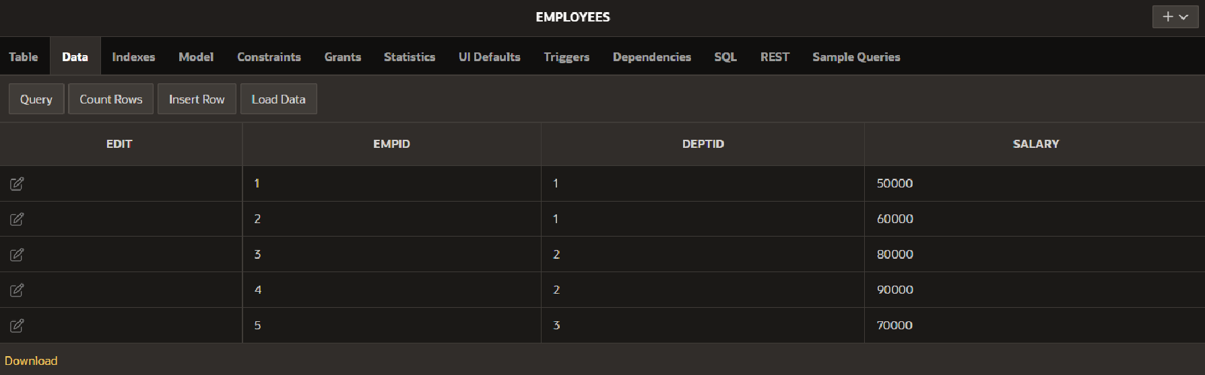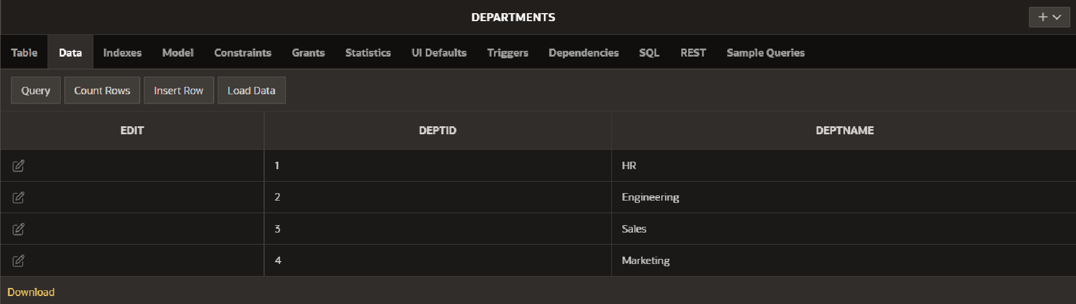

**Step 3: Write the SQL Query**

SELECT

d.DeptID,

d.DeptName,

AVG(e.Salary) AS AvgSalary

FROM

Departments d

LEFT JOIN

Employees e ON d.DeptID = e.DeptID

GROUP BY

d.DeptID, d.DeptName

ORDER BY

AvgSalary DESC

FETCH FIRST 3 ROWS ONLY;

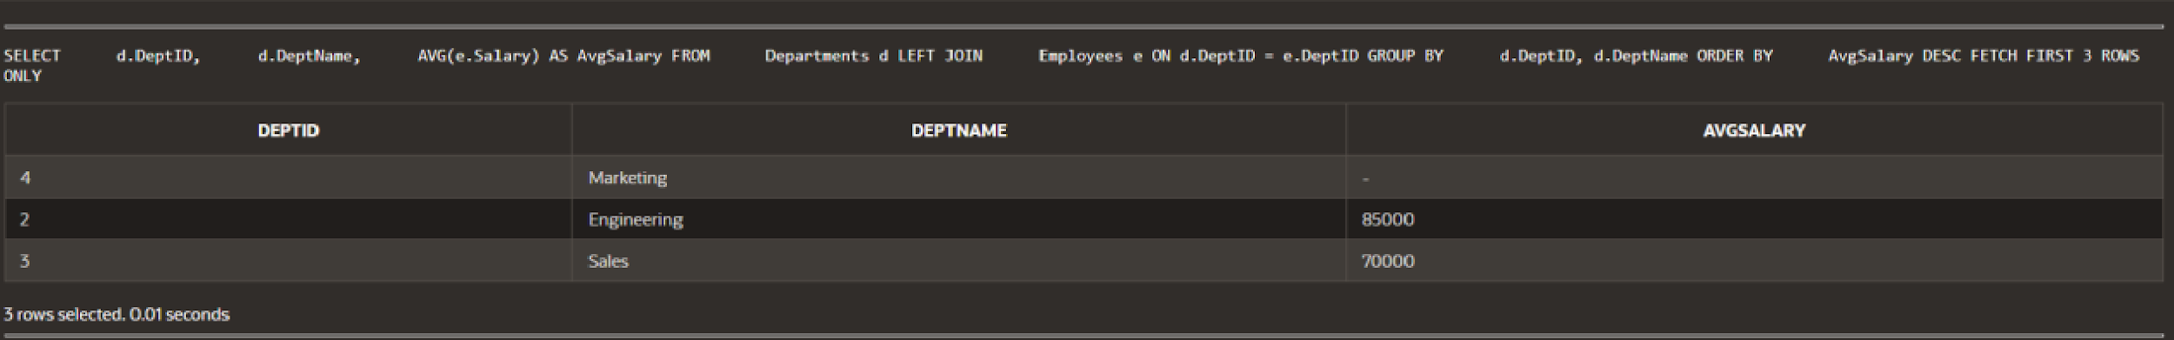

**Explanation:**

- Departments with No Employees: `LEFT JOIN` ensures that departments with no employees are included with `NULL` for `AvgSalary`.

- Average Salary Calculation: `AVG(e.Salary)` computes the average salary for each department.

- Result Limitation: `FETCH FIRST 3 ROWS ONLY` limits the results to the top 3 departments by average salary.

**Question 2: Retrieving Hierarchical Category Paths**

**Step 1: Create Table**

CREATE TABLE Categories (

CategoryID INT PRIMARY KEY,

CategoryName VARCHAR(100),

ParentCategoryID INT

);

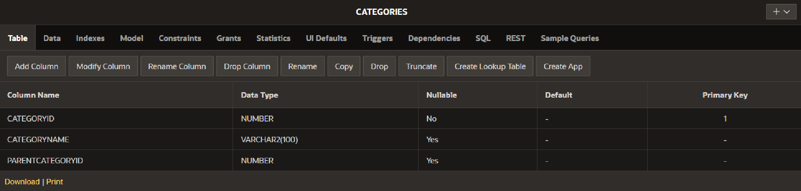

**Step 2: Insert Sample Data**

INSERT INTO Categories (CategoryID, CategoryName, ParentCategoryID) VALUES (1, 'Electronics', NULL);

INSERT INTO Categories (CategoryID, CategoryName, ParentCategoryID) VALUES (2, 'Computers', 1);

INSERT INTO Categories (CategoryID, CategoryName, ParentCategoryID) VALUES (3, 'Laptops', 2);

INSERT INTO Categories (CategoryID, CategoryName, ParentCategoryID) VALUES (4, 'Smartphones', 1);

INSERT INTO Categories (CategoryID, CategoryName, ParentCategoryID) VALUES (5, 'Accessories', 2);

**Step 3: Write the SQL Query**

WITH RECURSIVE CategoryPaths AS (

SELECT

CategoryID,

CategoryName,

ParentCategoryID,

CategoryName AS Path

FROM

Categories

WHERE

ParentCategoryID IS NULL

UNION ALL

SELECT

c.CategoryID,

c.CategoryName,

c.ParentCategoryID,

CONCAT(cp.Path, ' > ', c.CategoryName) AS Path

FROM

Categories c

JOIN

CategoryPaths cp ON c.ParentCategoryID = cp.CategoryID

)

SELECT

CategoryID,

CategoryName,

Path

FROM

CategoryPaths

ORDER BY

Path;

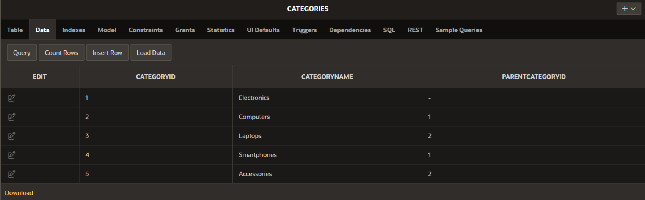

**Explanation:**

- Recursive CTE: `CategoryPaths` starts from root categories and recursively joins child categories to build paths.

- Base Case: Initial selection includes categories with `NULL` for `ParentCategoryID`.

- Recursive Case: Continues to build paths by joining parent categories.

**Question 3: Total Distinct Customers by Month**

**Step 1: Create Tables**

CREATE TABLE Customers (

CustomerID INT PRIMARY KEY,

CustomerName VARCHAR(100)

);

CREATE TABLE Purchases (

PurchaseID INT PRIMARY KEY,

CustomerID INT,

PurchaseDate DATE,

FOREIGN KEY (CustomerID) REFERENCES Customers(CustomerID)

);

CREATE TABLE CalendarMonths (

MonthNumber INT PRIMARY KEY,

MonthName VARCHAR(20)

);

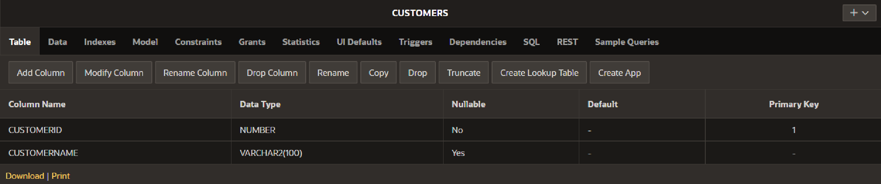

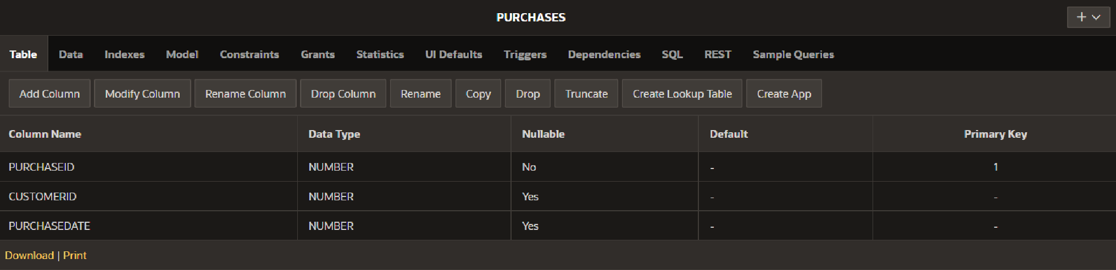

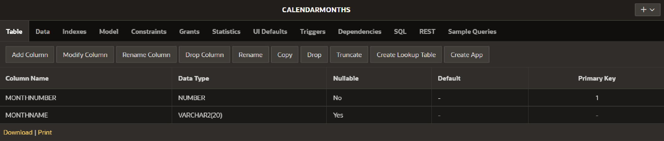

**Step 2: Insert Sample Data**

INSERT INTO Customers (CustomerID, CustomerName) VALUES (1, 'Alice');

INSERT INTO Customers (CustomerID, CustomerName) VALUES (2, 'Bob');

INSERT INTO Customers (CustomerID, CustomerName) VALUES (3, 'Charlie');

INSERT INTO Purchases (PurchaseID, CustomerID, PurchaseDate) VALUES (1, 1, '2024-07-05');

INSERT INTO Purchases (PurchaseID, CustomerID, PurchaseDate) VALUES (2, 2, '2024-07-15');

INSERT INTO Purchases (PurchaseID, CustomerID, PurchaseDate) VALUES (3, 1, '2024-08-20');

INSERT INTO CalendarMonths (MonthNumber, MonthName) VALUES (1, 'January');

INSERT INTO CalendarMonths (MonthNumber, MonthName) VALUES (2, 'February');

INSERT INTO CalendarMonths (MonthNumber, MonthName) VALUES (3, 'March');

INSERT INTO CalendarMonths (MonthNumber, MonthName) VALUES (4, 'April');

INSERT INTO CalendarMonths (MonthNumber, MonthName) VALUES (5, 'May');

INSERT INTO CalendarMonths (MonthNumber, MonthName) VALUES (6, 'June');

INSERT INTO CalendarMonths (MonthNumber, MonthName) VALUES (7, 'July');

INSERT INTO CalendarMonths (MonthNumber, MonthName) VALUES (8, 'August');

INSERT INTO CalendarMonths (MonthNumber, MonthName) VALUES (9, 'September');

INSERT INTO CalendarMonths (MonthNumber, MonthName) VALUES (10, 'October');

INSERT INTO CalendarMonths (MonthNumber, MonthName) VALUES (11, 'November');

INSERT INTO CalendarMonths (MonthNumber, MonthName) VALUES (12, 'December');

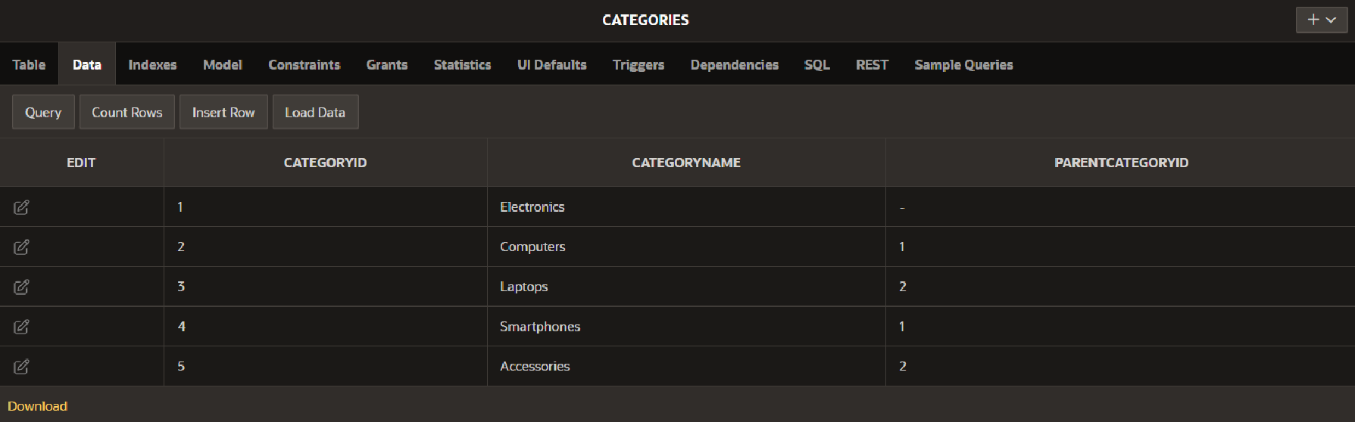

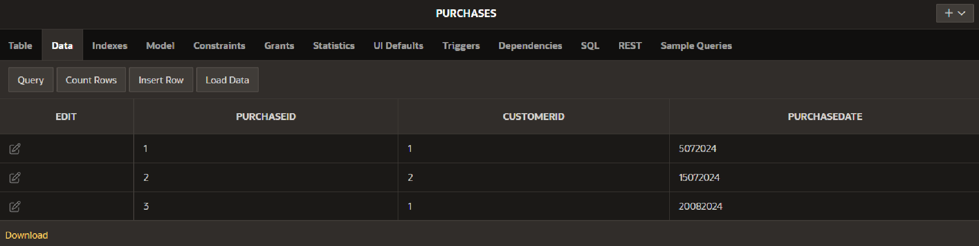

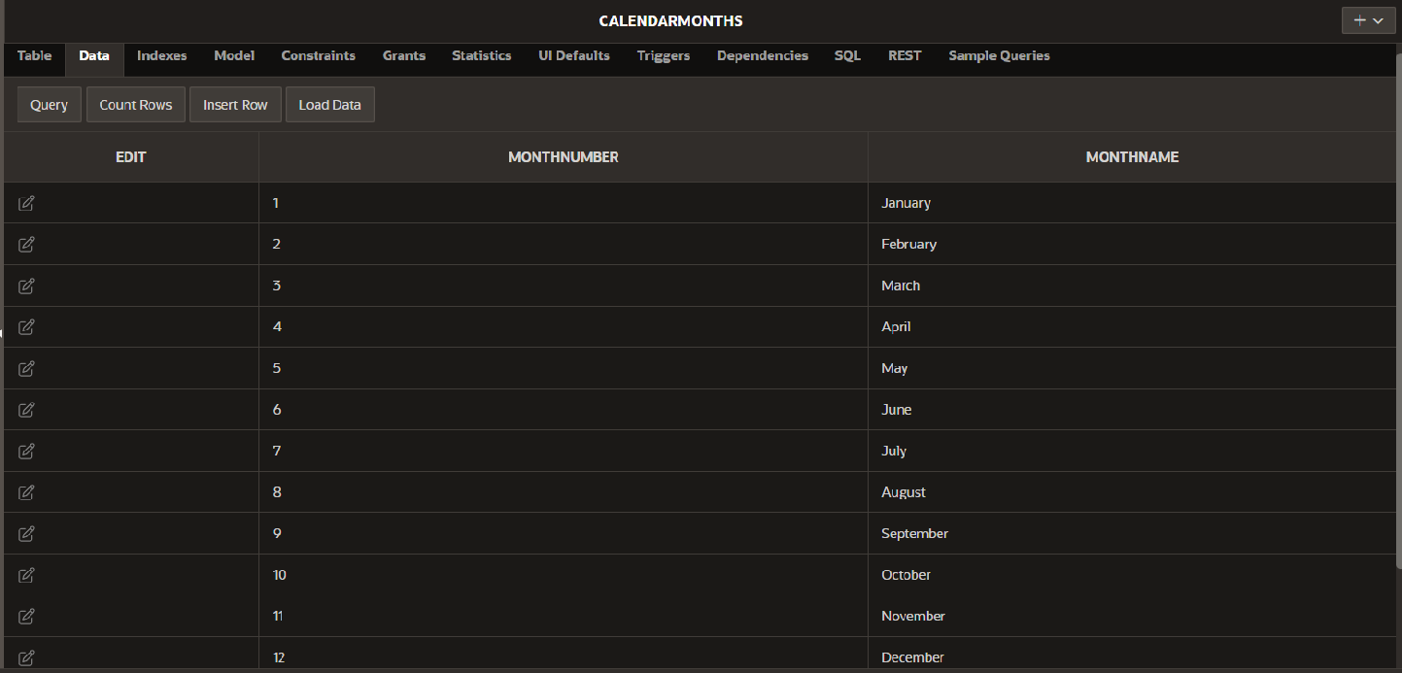

**Step 3: Write the SQL Query**

WITH MonthlyPurchases AS (

SELECT

TO_CHAR(p.PurchaseDate, 'MM') AS MonthNumber,

TO_CHAR(p.PurchaseDate, 'Month') AS MonthName,

COUNT(DISTINCT p.CustomerID) AS CustomerCount

FROM

Purchases p

WHERE

EXTRACT(YEAR FROM p.PurchaseDate) = EXTRACT(YEAR FROM SYSDATE)

GROUP BY

TO_CHAR(p.PurchaseDate, 'MM'), TO_CHAR(p.PurchaseDate, 'Month')

)

SELECT

cm.MonthName,

COALESCE(mp.CustomerCount, 0) AS CustomerCount

FROM

CalendarMonths cm

LEFT JOIN

MonthlyPurchases mp ON cm.MonthNumber = mp.MonthNumber

ORDER BY

cm.MonthNumber;

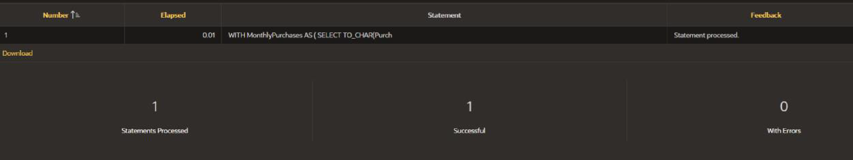

**Explanation:**

- Calendar Table: `CalendarMonths` ensures all months are covered.

- Distinct Customer Counts: `MonthlyPurchases` calculates distinct customers per month.

- Including Zero Counts: `LEFT JOIN` and `COALESCE` ensure all months are included, even those with zero activity.

**Question 4: Finding Closest Locations**

**Step 1: Create Table**

CREATE TABLE Locations (

LocationID INT PRIMARY KEY,

LocationName VARCHAR(100),

Latitude DECIMAL(9, 6),

Longitude DECIMAL(9, 6)

);

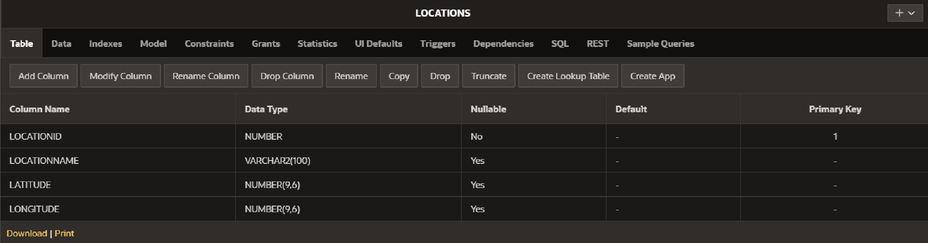

**Step 2: Insert Sample Data**

INSERT INTO Locations (LocationID, LocationName, Latitude, Longitude) VALUES (1, 'Location A', 40.730610, -73.935242);

INSERT INTO Locations (LocationID, LocationName, Latitude, Longitude) VALUES (2, 'Location B', 40.740610, -73.925242);

INSERT INTO Locations (LocationID, LocationName, Latitude, Longitude) VALUES (3, 'Location C', 40.750610, -73.915242);

INSERT INTO Locations (LocationID, LocationName, Latitude, Longitude) VALUES (4, 'Location D', 40.720610, -73.955242);

INSERT INTO Locations (LocationID, LocationName, Latitude, Longitude) VALUES (5, 'Location E', 40.710610, -73.965242);

INSERT INTO Locations (LocationID, LocationName, Latitude, Longitude) VALUES (6, 'Location F', 40.735610, -73.945242);

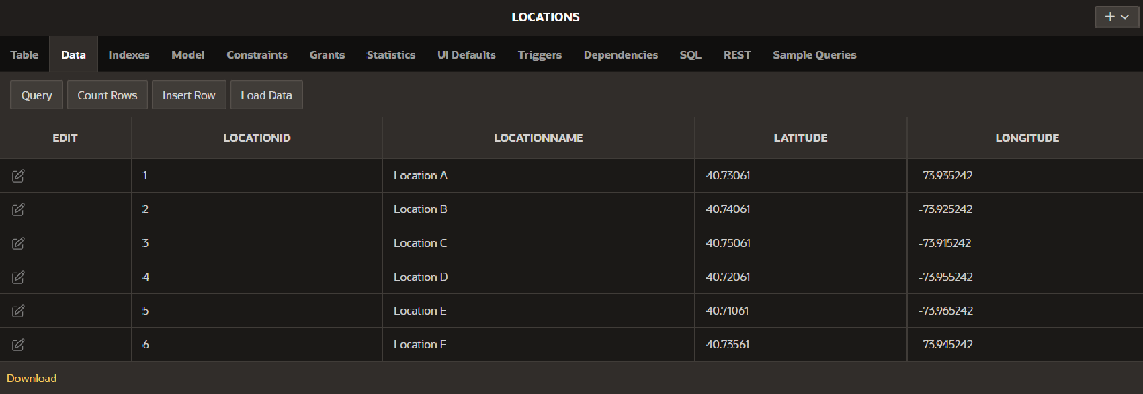

**Step 3: Write the SQL Query**

DECLARE

v_Latitude DECIMAL(9, 6) := 40.730610; -- Example Latitude

v_Longitude DECIMAL(9, 6) := -73.935242; -- Example Longitude

BEGIN

SELECT

LocationID,

LocationName,

Latitude,

Longitude,

(6371 * ACOS(

COS(RADIANS(v_Latitude)) * COS(RADIANS(Latitude)) *

COS(RADIANS(Longitude) - RADIANS(v_Longitude)) +

SIN(RADIANS(v_Latitude)) * SIN(RADIANS(Latitude))

)) AS Distance

FROM

Locations

ORDER BY

Distance

FETCH FIRST 5 ROWS ONLY;

END;

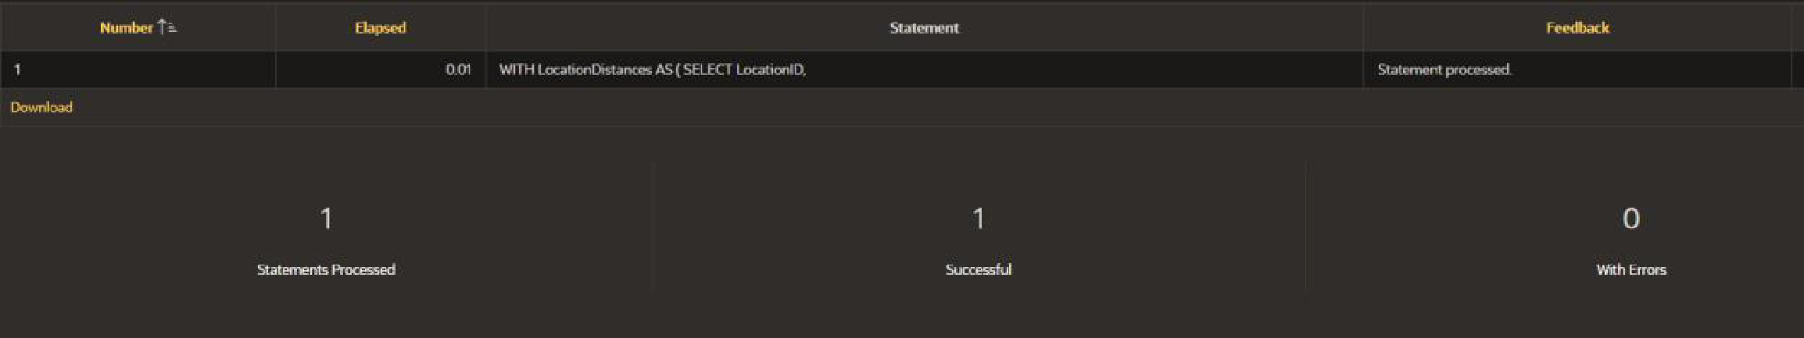

**Explanation:**

- Distance Calculation: Uses the Haversine formula to compute distances based on latitude and longitude.

- Ordering and Limiting: Results are sorted by calculated distance, and the closest 5 locations are returned.

**Question 5: Optimizing Query for Orders Table**

**Step 1: Create Table**

CREATE TABLE Orders (

OrderID INT PRIMARY KEY,

CustomerID INT,

OrderDate DATE,

TotalAmount DECIMAL(10, 2)

);

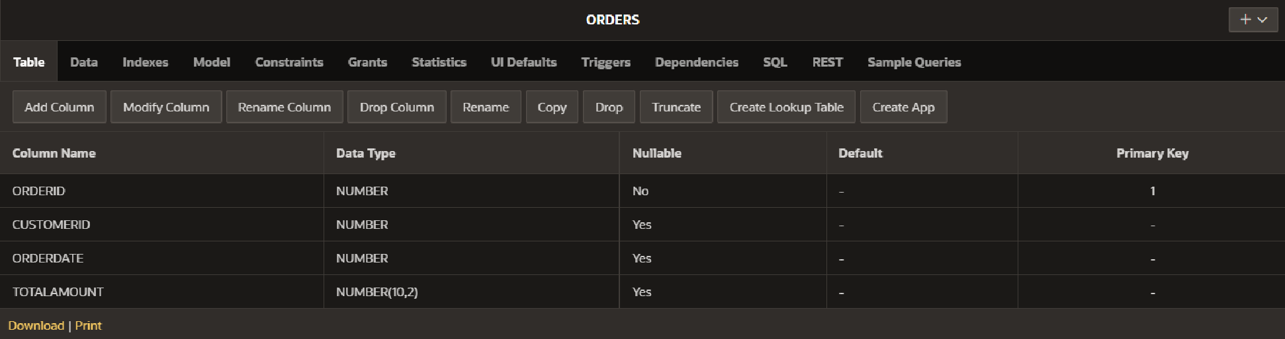

**Step 2: Insert Sample Data**

INSERT INTO Orders (OrderID, CustomerID, OrderDate, TotalAmount) VALUES (1, 1, '2024-07-25', 250.00);

INSERT INTO Orders (OrderID, CustomerID, OrderDate, TotalAmount) VALUES (2, 2, '2024-07-26', 150.00);

INSERT INTO Orders (OrderID, CustomerID, OrderDate, TotalAmount) VALUES (3, 1, '2024-07-27', 300.00);

INSERT INTO Orders (OrderID, CustomerID, OrderDate, TotalAmount) VALUES (4, 3, '2024-07-28', 100.00);

INSERT INTO Orders (OrderID, CustomerID, OrderDate, TotalAmount) VALUES (5, 2, '2024-07-29', 200.00);

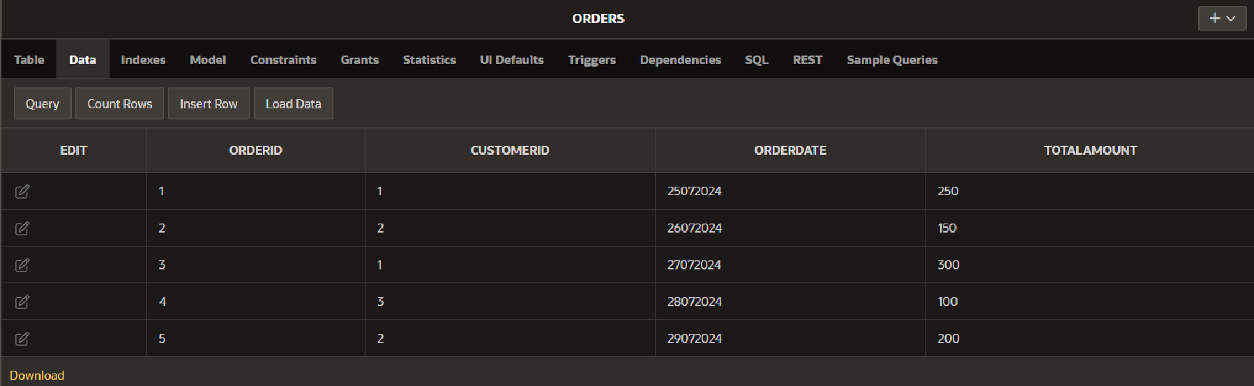

**Step 3: Write the SQL Query**

SELECT

OrderID,

CustomerID,

OrderDate,

TotalAmount

FROM

Orders

WHERE

OrderDate >= CURRENT_DATE - INTERVAL '7' DAY

ORDER BY

OrderDate DESC;

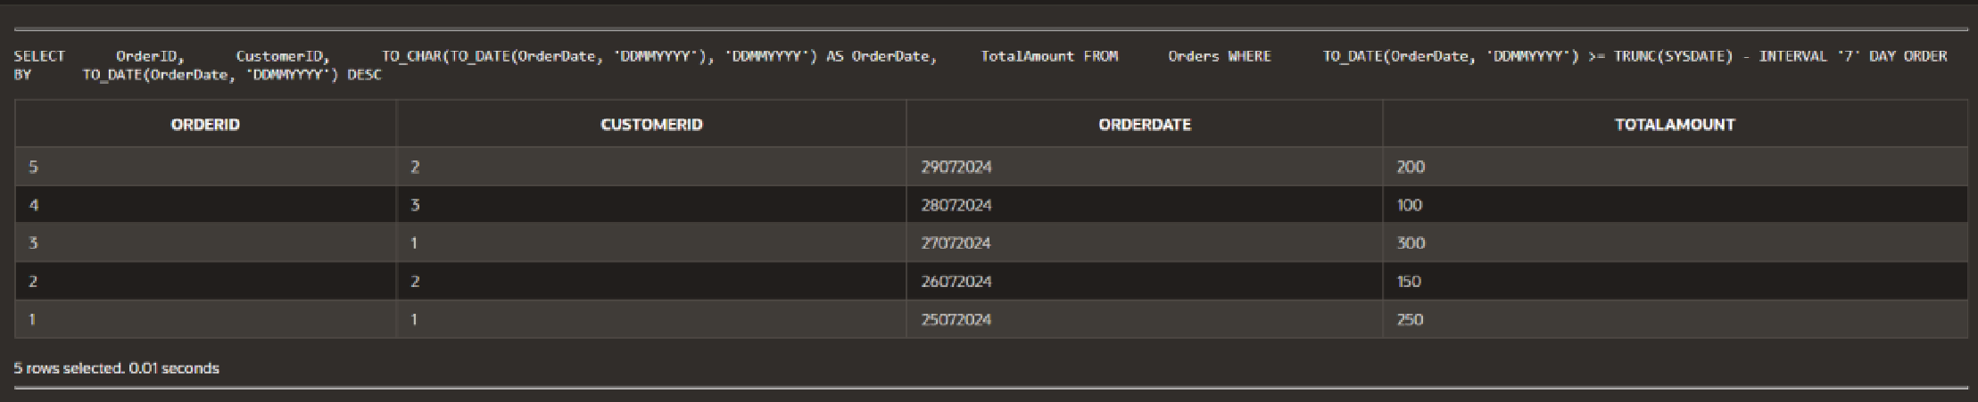

**Optimization Strategies:**

1. Indexing: Create an index on the `OrderDate` column to speed up queries filtering by date.

2. Query Rewriting: Using `CURRENT_DATE - INTERVAL '7' DAY` ensures efficient date range filtering.

3. Performance Monitoring: Regularly review execution plans and adjust indexes as needed based on query performance.